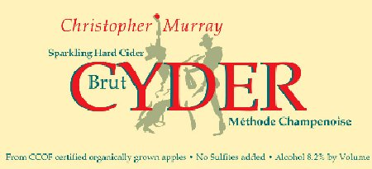Summary
Murray’s Cyder LLC,
P.O. Box 591,
Forestville, CA 95436-0591
Tel. +1 707 887 BRUT
Fax. +1 707 281 0868
e-mail chris@cyder.com
www.cyder.com
CA-W-2664
BW-CA-6241

The “champagne of ciders”, Christopher Murray Cyder is produced using the same methodology as fine champagne. Starting with organic apple juice, we use the classic “Méthode Champenoise” to achieve the tiny bubbles that tingle on the tongue with a moderate 8.2% alcohol. This also allows us to avoid completely the use of sulfites. Annual production is limited to 500 cases.

Details
We start with the juice of California Certified Organically grown apples from orchards in western Sonoma County. The juice is not filtered and not pasteurized.
Primary fermentation in tanks for about 6 months extracts the full flavor of the apple.
Secondary fermentation occurs when this flat hard cider is mixed with a “liqueur de tirage” and a fining agent and bottled. For the fining agent we use an inert French clay that is completely removed later in the processing. At this point the bottle has a metal crown cap, not a cork.
The bottles then lie undisturbed for at least a year in “tirage”.
During “tirage” the yeast converts the sugar of the “liqueur de tirage” into more alcohol and dissolved carbon dioxide.
When this process is complete, the yeast dies and forms “lees”.
Before the lees can be removed they are collected into the neck of the bottle in a process called “riddling” that involves gradually rotating the bottle in small steps as it is gradually tilted with its neck down. This is helped by the fining agent.
The neck of the bottle is then frozen so that the lees are trapped in a plug of ice. When the metal crown cap is removed, the pressure of the carbon dioxide forces this ice plug out of the bottle, leaving clear cyder.
A small amount of “liqueur d’expédition” is then added to provide balance. The quantity of sugar determines the type, and we make only “Brut”, the driest sweetened type.
Finally it is corked, wirehooded, labeled and foiled.
Basically just like champagne except we start with apple juice.
At no point do we add sulfites. In order for the label to state “no sulfites added” it must be shown to contain less than 10ppm. It was analyzed at the Bureau of Alcohol, Tobacco & Firearms laboratory in Walnut Creek. Their report shows that they detected none at all.

Result
A unique drink that captures the crisp taste of a freshly picked apple on a chill autumn morning.
For maximum enjoyment, serve well chilled, in a flute.

